**Digital Logic gates** (AND, OR, NOR, NAND, XOR)

Digital Computers

A Digital computer can be considered as a digital system that performs various computational tasks.

The first electronic digital computer was developed in the late 1940s and was used primarily for numerical computations.

By convention, the digital computers use the binary number system, which has two digits: 0 and 1. A binary digit is called a bit.

A computer system is subdivided into two functional entities: Hardware and Software.

The hardware consists of all the electronic components and electromechanical devices that comprise the physical entity of the device.

The software of the computer consists of the instructions and data that the computer manipulates to perform various data-processing tasks.

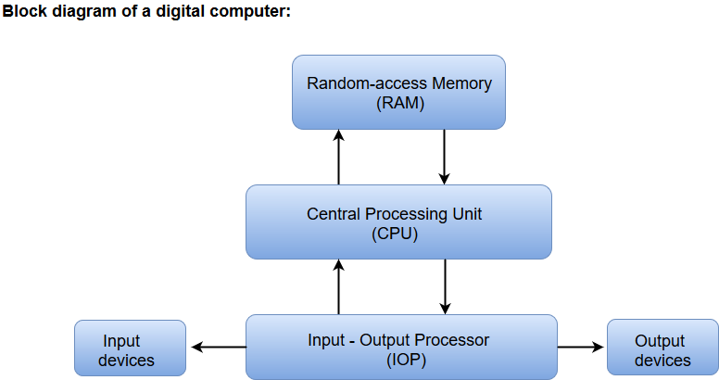

* The Central Processing Unit (CPU) contains an arithmetic and logic unit for manipulating data, a number of registers for storing data, and a control circuit for fetching and executing instructions.
* The memory unit of a digital computer contains storage for instructions and data.
* The Random Access Memory (RAM) for real-time processing of the data.
* The Input-Output devices for generating inputs from the user and displaying the final results to the user.
* The Input-Output devices connected to the computer include the keyboard, mouse, terminals, magnetic disk drives, and other communication devices.

Logic Gates

* The logic gates are the main structural part of a digital system.
* Logic Gates are a block of hardware that produces signals of binary 1 or 0 when input logic requirements are satisfied.
* Each gate has a distinct graphic symbol, and its operation can be described by means of algebraic expressions.
* The seven basic logic gates includes: AND, OR, XOR, NOT, NAND, NOR, and XNOR.
* The relationship between the input-output binary variables for each gate can be represented in tabular form by a truth table.
* Each gate has one or two binary input variables designated by A and B and one binary output variable designated by x.

AND GATE:

The AND gate is an electronic circuit which gives a high output only if all its inputs are high. The AND operation is represented by a dot (.) sign.

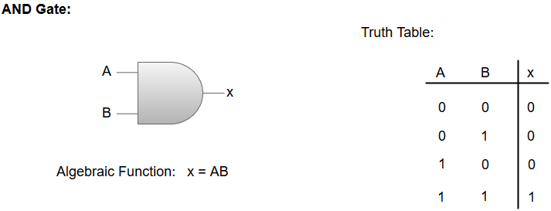

OR GATE:

The OR gate is an electronic circuit which gives a high output if one or more of its inputs are high. The operation performed by an OR gate is represented by a plus (+) sign.

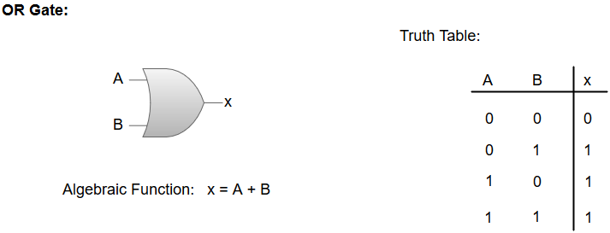

NOT GATE:

The NOT gate is an electronic circuit which produces an inverted version of the input at its output. It is also known as an **Inverter**.

NAND GATE:

The NOT-AND (NAND) gate which is equal to an AND gate followed by a NOT gate. The NAND gate gives a high output if any of the inputs are low. The NAND gate is represented by a AND gate with a small circle on the output. The small circle represents inversion.

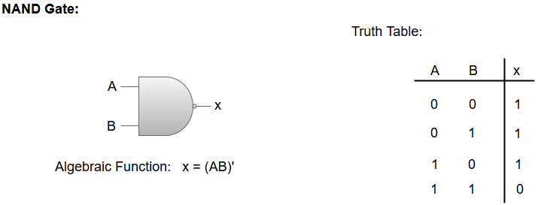

NOR GATE:

The NOT-OR (NOR) gate which is equal to an OR gate followed by a NOT gate. The NOR gate gives a low output if any of the inputs are high. The NOR gate is represented by an OR gate with a small circle on the output. The small circle represents inversion.

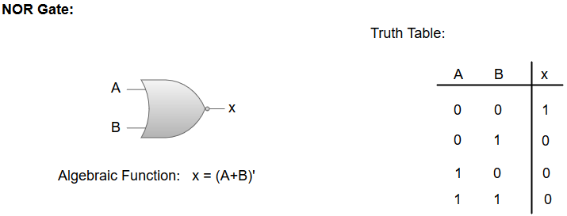

Exclusive-OR/ XOR GATE:

The 'Exclusive-OR' gate is a circuit which will give a high output if one of its inputs is high but not both of them. The XOR operation is represented by an encircled plus sign.

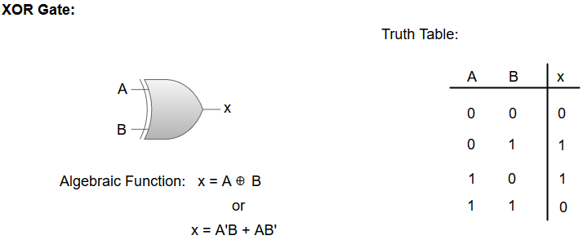

**EXCLUSIVE-NOR/Equivalence GATE:**

The 'Exclusive-NOR' gate is a circuit that does the inverse operation to the XOR gate. It will give a low output if one of its inputs is high but not both of them. The small circle represents inversion.

